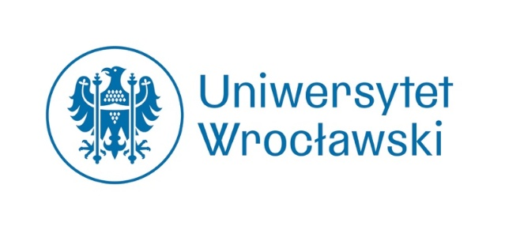

International Interdisciplinary Conference
Wrocław, May 20–22, 2026

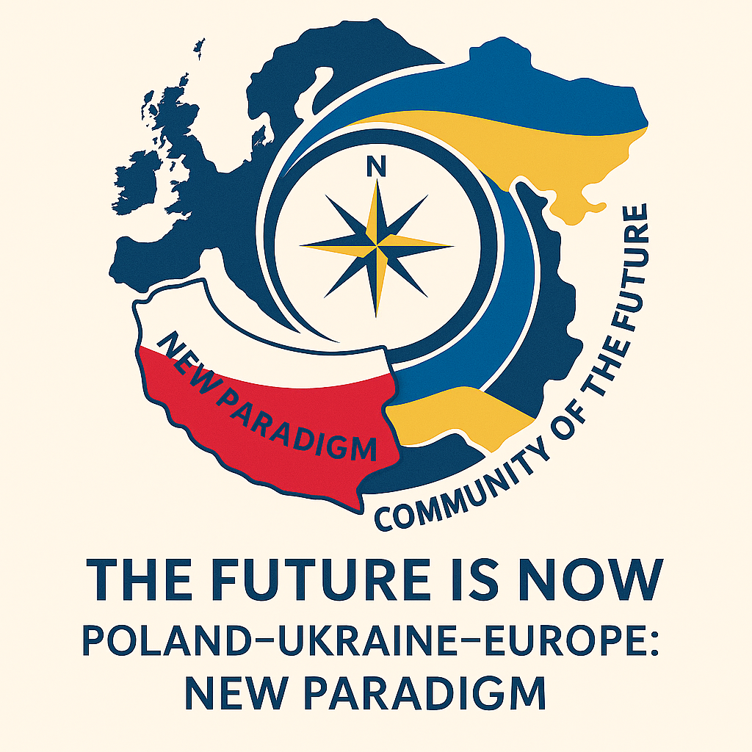

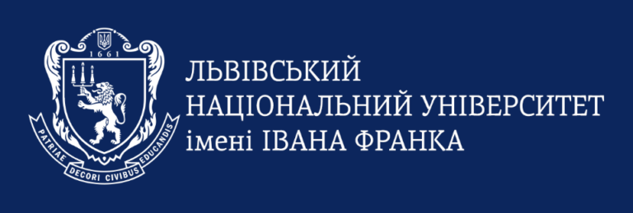
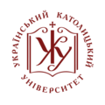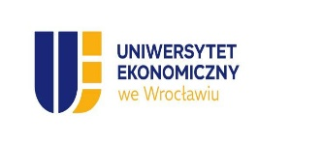

Call for Papers

Russia's aggression against Ukraine and Ukraine's efforts to join the European Union are reshaping Europe’s balance of power and values. Poland, as Ukraine's neighbor and a strong supporter of its sovereignty, plays a crucial role in shaping a new model of regional cooperation. The conference aims to analyze these transformations from the perspectives of political science, international relations, law, history, education, cultural studies, and economics.
In this context, the conference serves as an invitation to explore new challenges and opportunities for productive cooperation among Poland, Ukraine, and Europe amid war, reconstruction, and efforts to shape the region’s future. The organizers aim to create a platform for dialogue among researchers, experts, local government representatives, and civil society from various European and North American countries, creating a space for exchanging the latest knowledge, experiences, and recommendations in the research field.
The conference will officially launch the activities of the Center for Polish-Ukrainian Cooperation at the University of Wrocław, to be formally established in January 2026.

RESEARCH AREAS PROPOSED FOR DISCUSSION
The new geopolitical paradigm of Central and Eastern Europe
• The transformation of the international order after 2022: redefining security, sovereignty, and solidarity.
• The role of Poland and Ukraine in shaping the new European security architecture.
• Ukraine's integration with the EU and NATO: institutional, social, and cultural challenges.
• New alliances and dividing lines: Central and Eastern Europe amid global tensions (US, China, Russia).
Democracy, Civil Society, and Social Resilience
• Democratization and rebuilding Ukraine: models, risks, best practices.
• The role of civil society during war and recovery.
• Disinformation, propaganda, information warfare—how to foster social resilience.
• New forms of activism and transnational solidarity—ranging from humanitarian aid to academic cooperation.
Harmonization of Ukrainian law with European Union law
• Judiciary and public administration reform.
• Cross-border cooperation in criminal, civil, and administrative matters.
• Protecting human rights and upholding the rule of law.
• The importance of law in rebuilding the state and civil society.
Culture, Identity, and Memory for the Future
• National and European identity amid war and migration.
• Polish-Ukrainian cultural heritage—connecting history and future.
• Collective memory and historical policy—how to create a shared narrative?
• Culture as a tool for resistance and rebuilding—through art, literature, media.
Economy, Reconstruction, and Sustainable Development
• Ukraine's reconstruction scenarios: investments, infrastructure, green transition.
• Poland's role as a logistics and economic hub in the rebuilding process.
• New models of economic cooperation in the region – from local initiatives to macro-regional strategies.
• Energy security and the climate transition in the context of war.
Education, Science, and Innovation
• Universities as agents of social and political change – the role of academia in times of crisis.
• Academic mobility and the integration of students from Ukraine – challenges and successful practices.
• Joint research and educational projects – how to build lasting partnerships?
Digitalization, AI, and new technologies for education and reconstruction.

Two plenary panels dedicated to integration with EU requirements are also planned for the conference proceedings:
- Ukrainian science – with the participation of rectors from Polish and Ukrainian universities (comparing experiences, sharing best practices, exploring cooperation opportunities in the new post-war European paradigm); offering a new perspective on higher education – its impact on teaching, research development, and the shaping of values that should form a strong foundation for a new Europe.
- Ukrainian local government institutions – including Polish and Ukrainian local authorities from Wrocław’s partner cities and Lower Silesia's partner regions, as well as representatives from Wrocław’s academic circles.

PROPOSED TOPICS FOR THE STUDENT AND DOCTORAL SESSIONS
Contemporary Europe needs a new generation of researchers who are not only scientifically capable but also open to international collaboration, socially aware, and dedicated to creating a shared future. In this context, young researchers from Poland and Ukraine – students, doctoral candidates, and early-career scientists – play a crucial role in shaping an academic environment rooted in dialogue, solidarity, and common European values. Therefore, the organizers suggest discussing the following issues:
1. Identity, Memory, and Society
- The Younger Generation and the Shared History of Poland and Ukraine.
- Collective Memory and Historical Narratives in Education.
- National and European Identity from a Youth Perspective.
2. International Cooperation and European Integration
- Emerging Researchers’ Views on the Future of the EU and Ukraine's Role in European Structures.
- The Role of Youth in Building Civil Society.
- Cross-Border and Regional Cooperation in Central and Eastern Europe.
3. Media, Communication, and Disinformation
- Youth Attitudes Toward Disinformation and Information Warfare.
- Social Media as a Tool for Activism and Education.
- Media Collaboration and Journalistic Initiatives by Young Creators.
4. Peace, Security, and Human Rights
- Young Researchers on War and Peace—Legal, Economic, Sociological, Political, and Psychological Perspectives.
- Education in Human Rights and Democracy.
- Challenges Faced by Young Refugees and Migrants.

PLANNED ACCOMPANYING EVENTS
a) Master seminars for students, doctoral candidates, and early-career researchers
b) Polish-Ukrainian-English translation workshops
c) Photographic exhibition focused on war-related cultural destruction in Ukraine
d) Performative reading of Serhiy Zhadan’s drama A Harvest Truce.

Conference languages: Polish, Ukrainian, English
Conference fee: PLN 450 / EUR 100; students and doctoral candidates: PLN 300 / EUR 75. The bank account details for the conference fee will be sent with the acceptance confirmation. The fee will be used entirely for the preparation and publication of a peer-reviewed collection of conference papers in a listed publication. Participants from Ukraine are exempt from the conference fee.
Submissions: Please submit topics and abstracts (200-300 words) in Polish, Ukrainian, and English using the attached submission form. Include keywords and a biographical note (max. 80 words) for previously unpublished papers.
The deadline for submissions is January 31, 2026.
Notifications about accepted papers will be announced on February 20, 2026.

Email addresses for correspondence by subject area:
- law: prawo.future2026@uwr.edu.pl
- administration: admin.future2026@uwr.edu.pl
- economy: economy.future2026@uwr.edu.pl
- history: historia.future2026@uwr.edu.pl
- education: pedagog.future2026@uwr.edu.pl
- social science: social.future2026@uwr.edu.pl
- culture: kultura.future2026@uwr.edu.pl
- Polish Studies: filologia.future2026@uwr.edu.pl
- emerging scholars (students, doctoral students): young.future2026@uwr.edu.pl

ORGANIZING COMMITTEE
Lead Organizer: Faculty of Languages, Literatures and Cultures
Scientific director of the conference; chair of the Organizing Committee: Prof. Dr habil. Agnieszka Matusiak-Bakuła, Director of the Center for Polish-Ukrainian Cooperation at the University of Wrocław and Department of Ukrainian Studies (Institute of Slavic Studies).
University of Wrocław’s units co-organizing the conference and members of the Organizing Committee:
- Faculty of Languages, Literatures and Cultures: Coordinator: Dr. habil. Mateusz Świetlicki, prof. UWr
- Faculty of Law, Administration and Economics. Coordinators: Prof. Dr. habil. Maciej Marszał; Dr. Daniel Butyter, Dr. habil. Barbara Kowalczyk, Dr. habil. Magdalena Tabernacka, prof. UWr
- Faculty of Social Sciences. Coordinator: Dr. habil. Larysa Leshchenko, prof. UWr
- Faculty of Letters. Coordinator: Dr. habil. Jan Choroszy, prof. UWr
- Faculty of Historical and Pedagogical Sciences. Coordinators: Prof. Dr. habil. Jarosław Syrnyk; Dr. hab. Karol Sanojca, prof. UWr; Dr. Anna Haratyk
- International Office: Urszula Broda
- WUSA – Community of Ukrainian Students and Scholars at the University of Wrocław. Coordinator: Daniel Bielecki
Conference secretariat: Viktoriia Kushnir and Arsen Yatsenko
Strategic Polish Academic Partners:
- General Tadeusz Kościuszko Military University of Land Forces in Wrocław. Coordinators: Dr. habil. Izabela Nowicka, Prof. AWL, and Lt. Col. Dr. Eng. Piotr Szczepański
- Wrocław University of Economics and Business, Coordinator: dr habil. Natalia Szozda, prof. UEW
Strategic Ukrainian Academic Partners:
- Taras Shevchenko National University of Kyiv. Coordinator: Prof. Dr. habil. Ksenia Smyrnova
- Ukrainian Catholic University in Lviv. Coordinator: Prof. Dr. habil. Oleksandr Pronkevych
- Foundation of the Ukrainian Catholic University in Wrocław. Coordinator: Khrystyna Fogel
- Ivan Franko National University of Lviv. Coordinator: Dr. Assoc. Prof. Oleksandr Kuchyk
Strategic National Institutional Partners:
- Office for International Cooperation, Presidential Division, Wrocław City Hall. Coordinator: Sara Blejwas
- Office for Cooperation with Higher Education Institutions, Wrocław City Hall. Coordinator: Monika Sochacka
- Department for International Cooperation, Marshal’s Office of the Lower Silesian Voivodeship. Coordinator: Aleksandra Mirowska-Piełucha
- Academia Europaea Wrocław Hub. Coordinators: Anna Jarosz and Veronica Lott
- The Ossolineum (National Ossoliński Institute) in Wrocław. Coordinator: Dr. Wiktoria Malicka
- University Library in Wrocław; Coordinator: Dr. Monika Górska
- Pan Tadeusz Museum in Wrocław. Coordinator: Oleksandra Stezhko

